[University Name]

[Course Name] - [Course ID]

Final Project

[Student Name]

[Student ID]

2021-2022

2nd Semester

# 1. Specification

In this section, we explain the business requirements of the web-based software project.

## 1.1. Admin Panel

1. Books Management
   1. Add new book: the admin panel provides a feature of adding new book with its name, author, publishing year; with pre-condition of the both name and publishing year together, as one field, is prevented from be repeated in the database.
   2. .....
   3. ....
2. Authors Management: .....
3. Etc...

## 1.2. Public Website

1. ....
2. .....
3. Etc...

# 2. Software Design

In this section, we present high-level design of the software.

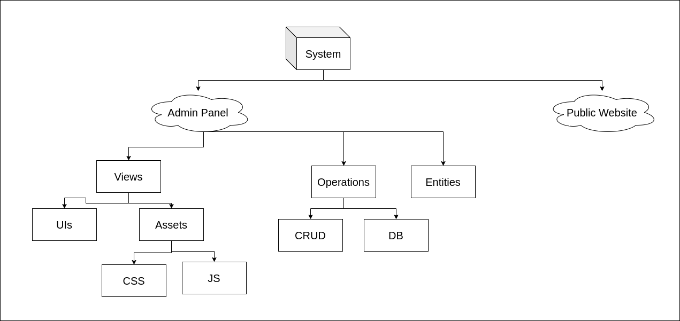

## 2.1. Admin Panel

1. Views: contains all files related to UIs and its style and JS libraries ...
2. Etc...

## 2.2. Public Website

1. Views: contains all files related to UIs and its style and JS libraries ...
2. Etc...

# 3. Implementation

In this section, we present a screenshots of code snippets of most important features.

Such as:

Code snippet of adding book and check no duplication

Code snippet of get “add book” form view

Etc...

# 4. Bonus Features

….

# 5. Other Bonus Features

….